|  |  |  |  |
| --- | --- | --- | --- |
|  | Bansilal Ramnath Agarwal Charitable Trust's  Vishwakarma Institute of Information Technology  Department of  Artificial Intelligence and Data Science | | |
| Name: Siddhesh Dilip Khairnar | | | |
| Class: SY-B tech | Division: B | | Roll No: 272028 |
| Semester: 3rd | | Academic Year:2022-2023 | |
| Subject Name & Code: ADUA21206 - Data Visualization | | | |
| Title of Assignment: Hierarchical Category Visualization | | | |
| Date of Performance: 13/10/2022 | | Date of Submission: 14/10/2022 | |

Aim: Visualize the dataset using hierarchical category: Tree diagram and ring charts/Sun Brust.

Problem Statement: Download data set from Kaggle/Tableau/data world. Visualize the dataset using hierarchical category: Tree diagrams and ring charts/sun Brust.

Theory/Writeup:

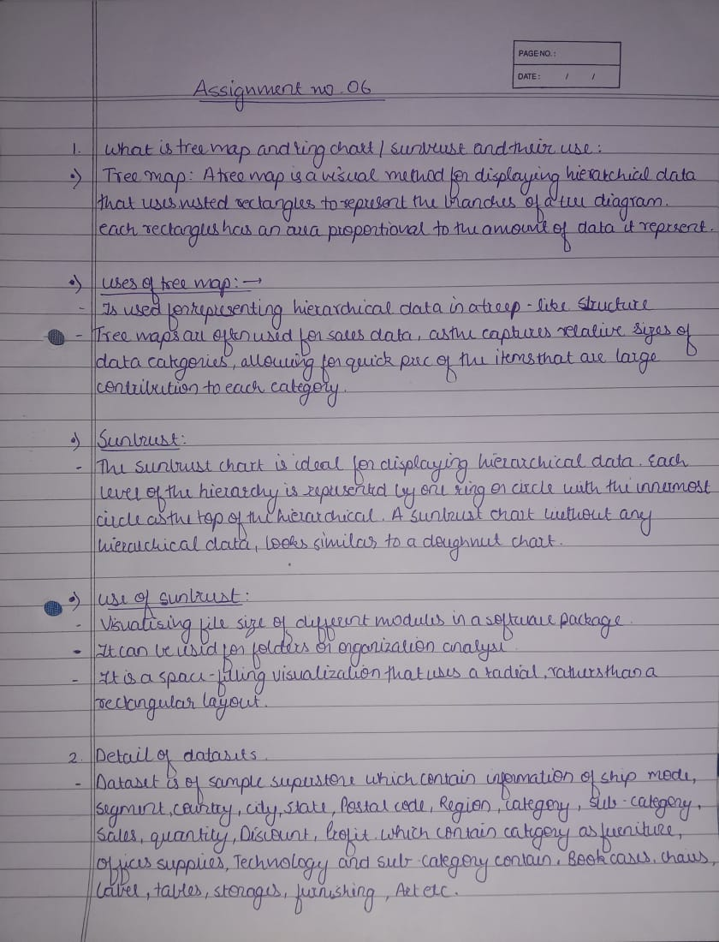

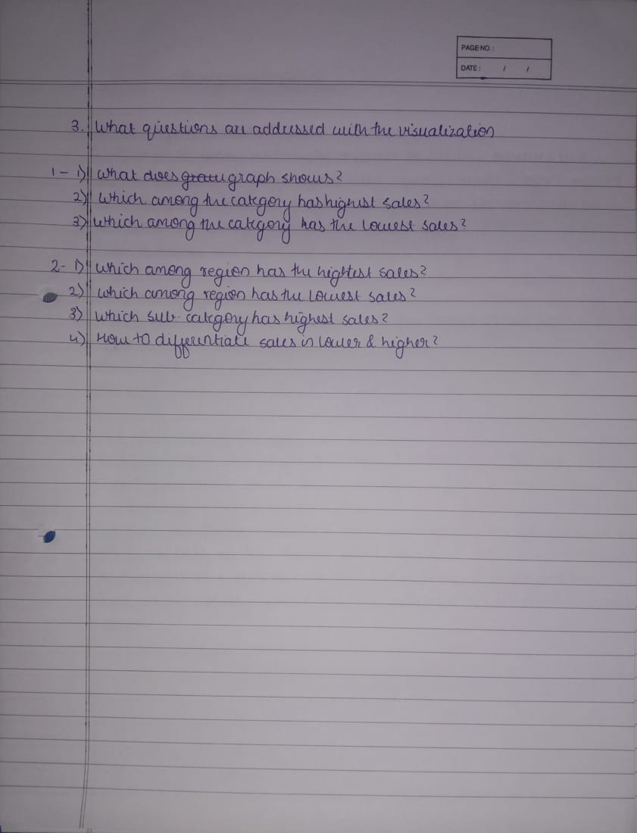

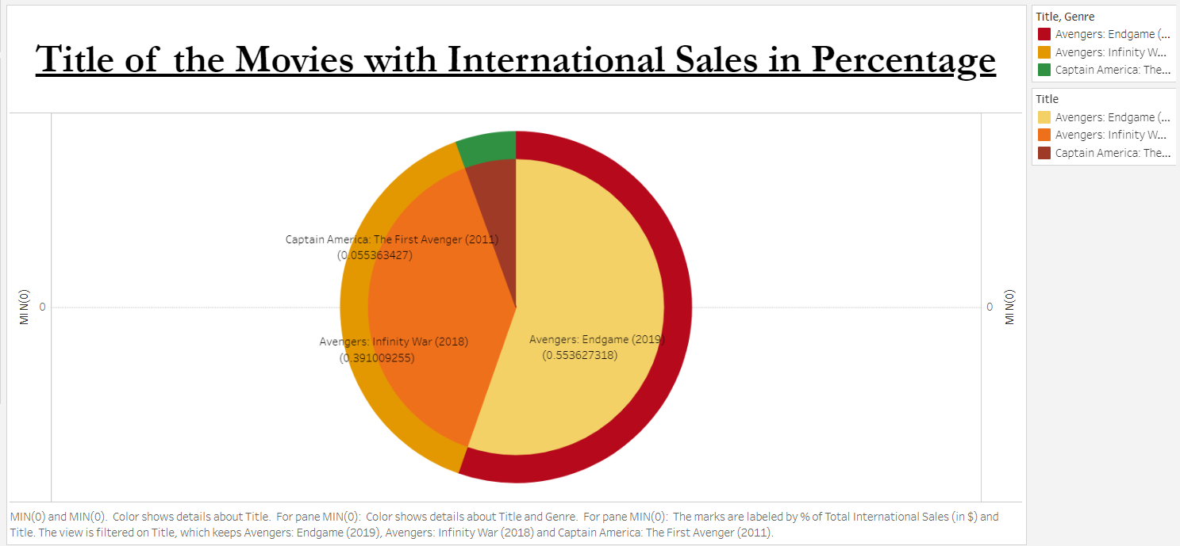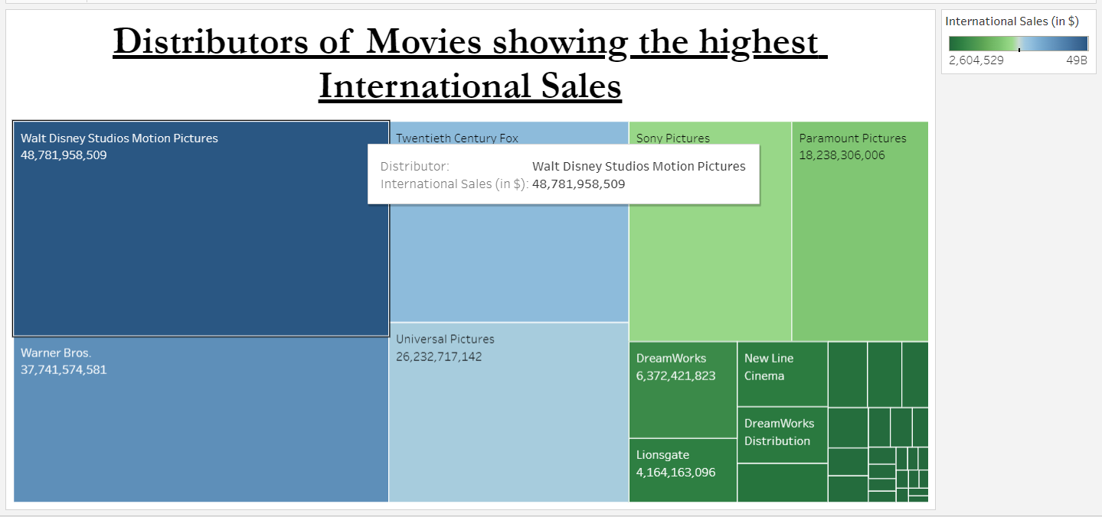

Tableau Public Profile Link:

1.<https://public.tableau.com/authoring/B_28_SiddheshKhairnar_DV_ASS_6/Sheet1#1>

2.<https://public.tableau.com/authoring/B_28_SiddheshKhairnar_DV_ASS_6/Sheet2#1>